Design and Development of Instructional Module Development System (IMODS) for Mobile Devices

SOHAN MADHAV BANGARU,

Graduate Student, Software Engineering, CIDSE, Arizona State University, [smbangar@asu.edu](mailto:smbangar@asu.edu)

Instructional Module Development System (IMODS) is a web application that guides instructors through an outcome-based course design process. The underlying theoretical framework of the IMODS strongly adheres to Outcome based Education (OBE) [3 ,4, 5, 6] approach which treats the objectives as the spine of a course. This report presents the background on IMODS framework, key components of IMODS, and the guidance provided the tool to STEM educators. This project specifically focuses on the ,of This report presents the basic components of the IMODS framework and how these components are translated to the mobile environment. This report presents the details of system architecture, UI design, and the design of the underlying database for the mobile environment. It also discusses how the model view controller (MVC) [25] approach was used to modularize the functionalities of IMODS. This report also describes the various screens present in the application and their respective functionalities along with the transition between their screens. This report finally describes testing approaches used, usability analysis performed for this project, and future enhancements.

CCS Concepts: • **Information systems → Information systems applications → Mobile information processing systems**; • **Human centered computing → Ubiquitous and mobile computing**

General Terms: Design, Documentation, Human Factors

Additional Key Words and Phrases: Mobile application development, User centered design, MVC architecture

1 INTRODUCTION

There are a lot of tools in the mobile market that help STEM educators manage course planning, resource sharing, grading, and course administration [14-23]. To ensure future generations of engineering, science and other technological practitioners are equipped with the required technical know-how and skills to constantly innovate solutions to societal challenges, effective courses that incorporate the best pedagogical and assessment practices must be developed and delivered. Instructional Module Development System (IMODS) is a web application that guides instructors through an outcome-based course design process. The underlying theoretical framework of the IMODS strongly adheres to Outcome based Education (OBE) [3, 4, 5, 6] approach which treats the objectives as the spine of a course. In the IMODS framework, course design is centered around the learning objectives of a course. The learning objectives should have following defining characteristics: Performance – description of what the learner is expected to be able to do, Condition – description of the condition under which the performance is expected to occur, Content – description of the factual, procedural, conceptual and meta-cognitive knowledge and Criteria – description of the level of competence that must be reached or surpassed. The underlying theoretical framework for IMODS called the PC3 Model is discussed in detail in the next section.

Effective course design includes creation of learning objectives, content topics, assessments, and instructional techniques. Instructors often use diverse tools to help with design of these various components. It often gets increasingly difficult to manage course planning and tracking across different applications effectively. The goal of IMODS was to bring together these functionalities under one umbrella and ensuring that an outcomes-based education process was followed for course design. To further extend the ease of using IMODS tool, a mobile version of the application is being designed targeting tablet-sized mobile devices for the first version. It also brings a set of unique challenges of designing intuitive User Interface (UI) and various transitions to enable the educator to use the application with ease. This report presents the first version of IMODS Mobile and discuss various design and implementation aspects of the mobile application.

This report briefly describes the reference application used to create the mobile version of IMODS and its various sub-modules, research and categorize various tools which already exist in the market for the user in the mobile space, discuss briefly the system architecture diagram, describe the detailed design using interaction diagrams and the database design of the application. This report also discusses how the model view controller (MVC) [24, 25] architecture was adopted and specify various view controller elements and their interactions made between them. The navigation between these view controllers are demonstrated using the navigation diagram. This report briefly project development activities and source code management was performed. The report also specifies the testing methodologies used during the development phase, the user studies performed and their result analysis and finally the future direction of the mobile application for IMODS.

2 BACKGROUND

IMODS framework is primarily built on the guidelines of Outcome-based Education (OBE). OBE is a result-oriented approach is where the product defines the process [3, 4, 5]. The learning outcome decides as to what is to be taught and assessed. This style of education is in a stark contrast to traditional “input-based learning” where the key focus lies in the course content and not on the outcome of the course instruction. This model is typically a win-to-win solution for all the stakeholders; it has led to a variety of student successes and shown significant high achievement test scores, improved attendance and motivation. It also provides educators with empirical driven structure for tracking the course impact and identifying problems. There is a growing demand for OBE for faculties imparting education across various professional development areas [4, 5].

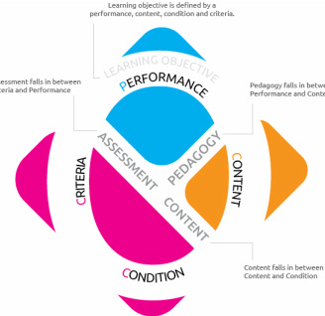

Fig. 1. PC3 Model for IMODS Framework

The IMODS Framework strongly adheres to the OBE approach and the course design is entirely revolving the learning objectives defined for the course. There are three defining characteristics of a learning objective namely, (i) Performance – which is a description of what the learner is expected to be able to do [9], (ii) Condition – a description of the conditions under which the performance is expected to occur [9], (iii) Criteria – a description of the level of competence that must be reached or surpassed and lastly [9] (iv) Content – a description of disciplinary knowledge skill or behavior to be attained. This is the PC3 model helping to design a learning objective for the course [9]. There are other design elements like course content, pedagogy and assessment, where course-content is linked to content and condition components of the objective, course-pedagogy is linked to the performance and content components of the objective and assessment is linked to the performance and criteria components of the objective [9, 10].

In recent times, to equip the educators with a comprehensive solution, to help them plan a well-conceived curriculum and to train and teach STEM courses in an effective and efficient manner, a web-based application for IMODS (Instructional Module Development) for the educators was designed and delivered to primarily use it on the PCs or laptops [11. 12]. The plan is to take it to the next step to provide a mobile version of IMODS application to use it with ease on their iPads and other mobile tablet environments. This idea of building a mobile version was conceived for the following major reasons: (i) increasingly the internet users mostly use smart phones / tablets as compared to the PCs or laptops for the reason being it mobile, simple and intuitive, (ii) providing the service of IMODS application across various mobile devices would increase the overall user-base and effectively produce wider app penetration and representation, (iii) increased representation helps in making informed decisions and provide valuable insights on new application features to be developed and provide app improvements further to the overall application. To further keep the focus on the next steps it was decided to first design and develop the mobile application on the native apple based iOS devices. Also, the other reason is that most of the educators use the OSX based Apple PCs and iOS based iPhones / iPads for imparting the curriculum to their students. Finally, after performing sufficient research and with multiple consultations with my faculty mentor it was decided to take up iOS based iPad to begin with the IMODS representation in the mobile environment.

3 RELATED WORK

In the mobile space these are four main categories of tools or applications which help the educators impart course content. The categories are (i) Tools for K-12, (ii) Learning Management Systems (LMS), (iii) Massive Open Online Courses (MOOCs) and (iv) Targeted Tutorials. The categories are briefly described with their differences and with examples below:

*3.1 Tools for K-12 -* There are certain applications targeting individual concepts and topics targeting mostly kids from pre-school up until K-12 which are developed by mostly individuals to achieve a single objective most of the times. This kind of education imparting becomes a part of informal learning techniques which are just barely sufficient for the learners who are till K-12 or below. These applications are mostly game-based like quizzes (primarily for informal assessment), cue-card styled information (primarily for learning content) etc. There also certain applications which aid the learners finish their homework for like (E.g. iHomework [14], Graphmatica [15] etc.) which are very narrowly focused on content topics they deal with

*3.2 Learning Management System (LMS) –* These is a category of software applications that helps in administration, documentation and reporting of the progress of the course in the classrooms. These applications mostly delegate certain duties of the faculties by providing an interface through which the learners can view subject notes, answer questions related to topics, generate automated tests and grade them simultaneously. Some of the applications which come under this category are Blackboard [16], Moodle [17].

*3.3 Massive Open Online Courses (MOOCs) –* MOOC is an online platform which are aimed at unlimited participation via the internet. In addition to traditional course materials such as recorded lectures, readings and problem sets many MOOC providers provide interactive under forums to support community interactions among students, professors and teaching assistants. It is a recent and widely researched development in distance education providers and has emerged has one of the most popular modes of learning. Some of the applications which come under this category are Coursera [18], Khan Academy [19], Udacity [20].

*3.4 Targeted Tutorials –* These are tailor-made course content dealing with very specific and boxed technical areas and learnings which are mostly used by the professionals to skill themselves for a required targeted objective. There are mostly skilling programs or tutorials mostly used to learn the application of a concept, content or a library, rather than its history and evolution of the system or tool. Some of the examples are Udemy [21], Lynda [22], Code School [23] which come under the umbrella of targeted tutorials.

Most of the stated

4 DESIGN

4.1 SYSTEM ARCHITECTURE

The system architecture describes the overall component level system arrangement that is used for developing the IMODS application for mobile environment. It also describes the basic components used in the iOS App development supported by the operating system of the mobile environment.

IMODS Mobile Application

Core Data

Cocoa Touch

Application Delegate

iOS System Frameworks

API Layer

Fig. 2. System Architecture Diagram for IMODS Mobile Application for iOS Environment

IMODS Mobile Application for this prototype version is currently made to support iOS Environment for iPads and related tablet specific models. IMODS mainly uses the following utilities provided by API interface: (i) **Core Data:** This is an in-house database support provided for iOS Application which uses the Object Relational Model (ORM) [27] to communicate to the application components. (ii) **Cocoa Touch:** This is the interface which enables developers to create View Controllers for the screens. This module also helps using predefined widgets and tools necessary for the developers. (iii) **Application Delegate:** This provides to entry point to application to control certain behaviors at the life stages of the Application. (iv) **iOS System Frameworks:** This provides the overall iOS System environment to access operating systems’ functionalities and other services.

4.2 DETAILED DESIGN

This subsection tries to illustrate the detailed design of the IMODS mobile application. This section contains mainly shows the use-case diagram of the application, illustrated interactions diagrams between the various view controllers to perform the required use –case and finally depict the database diagram used for the mobile application. These use-case diagrams and the interaction diagrams were prepared using a tool named Astah [26].

4.2.1 Use-Case Diagrams.

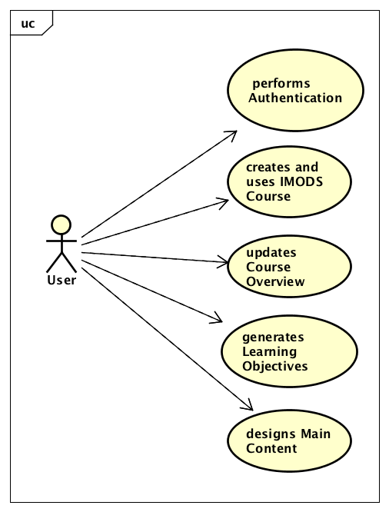

Fig. 3. Mobile Application Use-Case Diagram

The Use-case diagram depicts the various functions the end-user can perform on the first version of IMODS Mobile Application.

4.2.2 Interaction Diagrams

The initial sequence diagram is as follows:

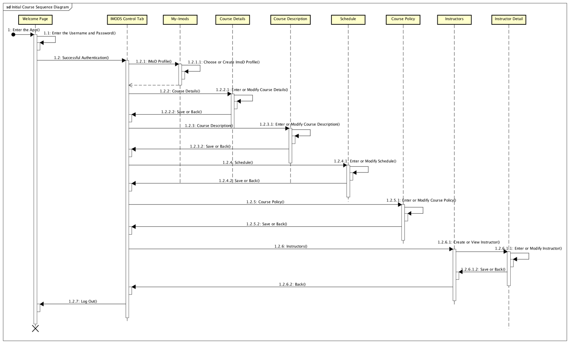

Fig. 4. Initial Sequence Diagram for IMODS Application

The initial sequence diagram depicts the various View Controllers present in the project and a snapshot of how all the interaction between the views take place when the app is loaded for the first time.

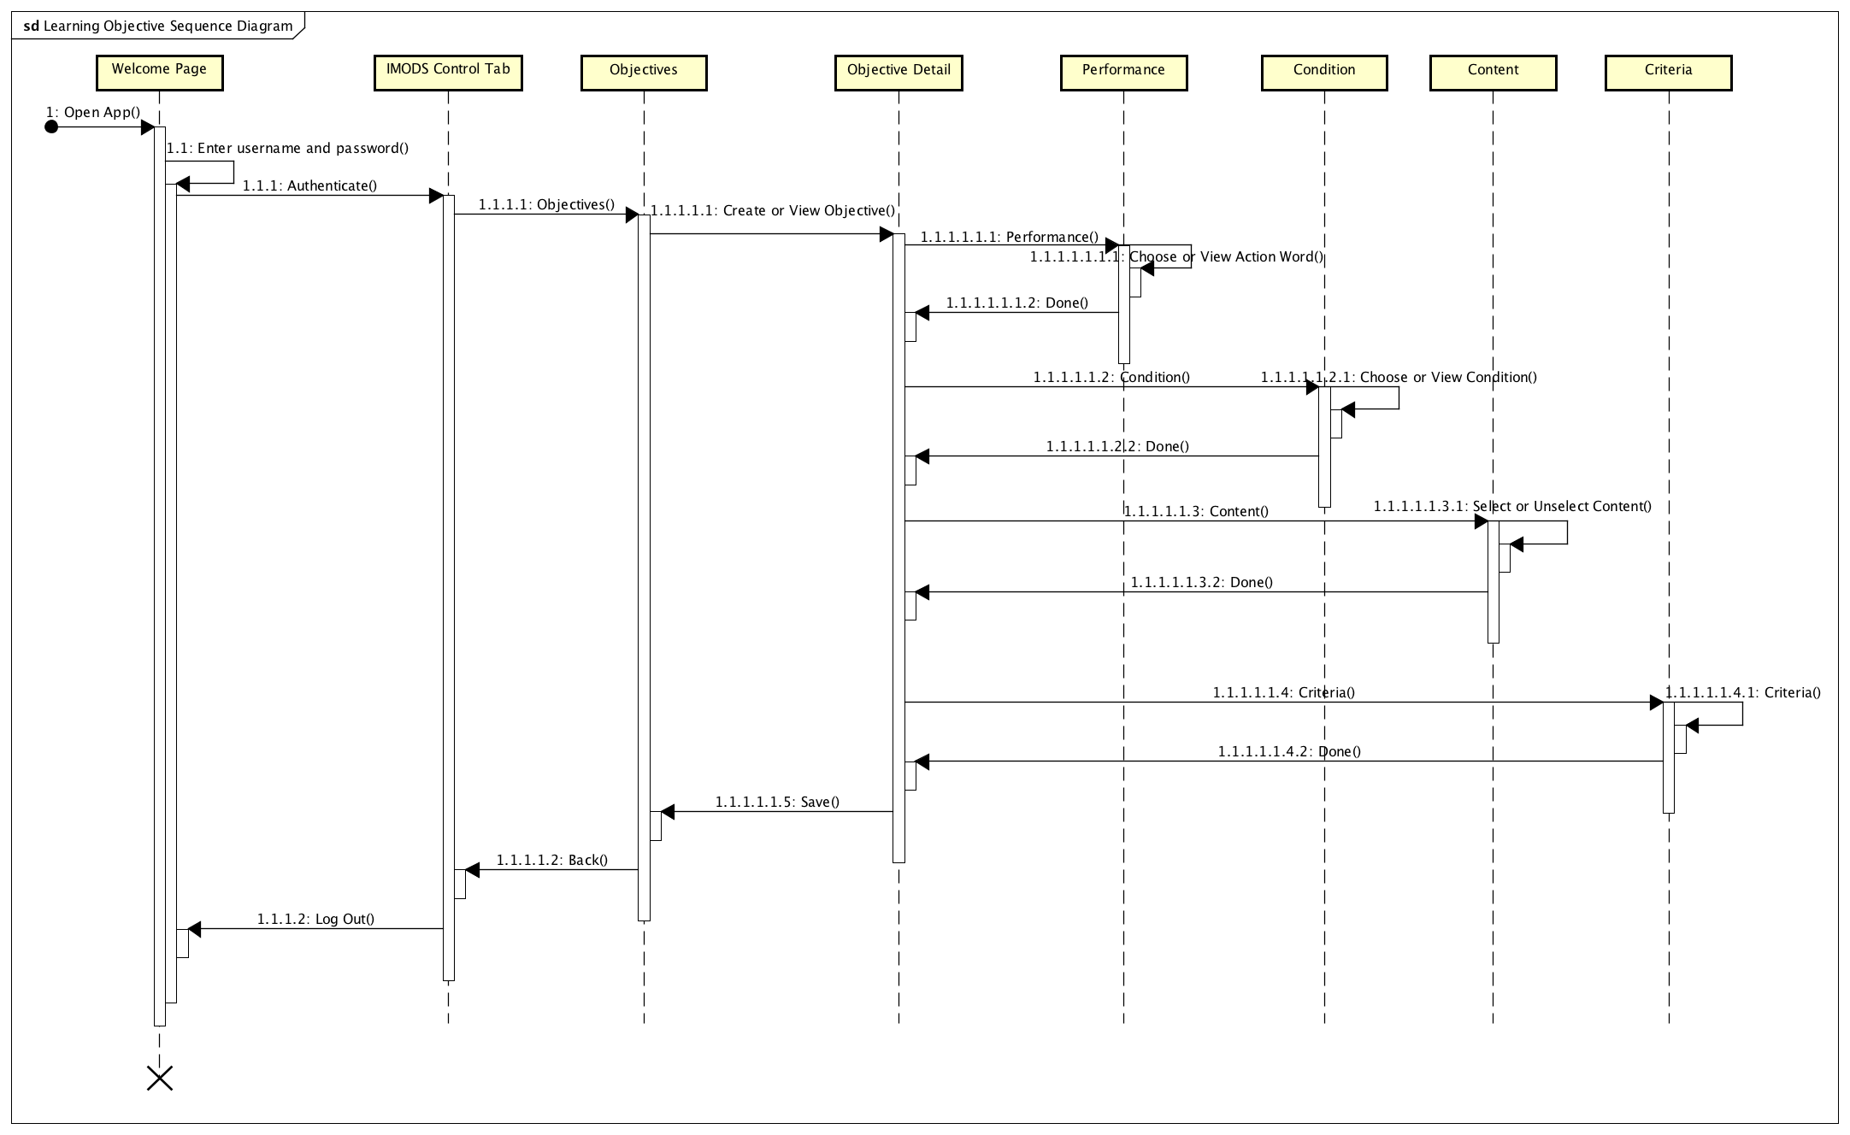

Fig. 5. Learning Objectives Sequence Diagram

The learning objectives sequence diagram depicts the various View Controllers present when a new learning objective is created for a course under the my-imods object.

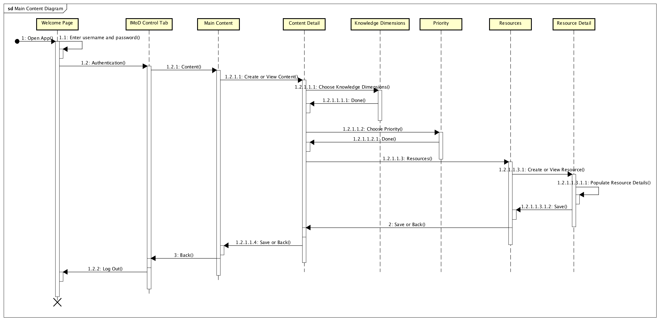

Fig. 6. Main Contents Sequence Diagram

Main Content Sequence Diagram depicts how various view Controllers present when creating a new content topic for a course under My-imods object.

4.2.3 Database Design Diagram

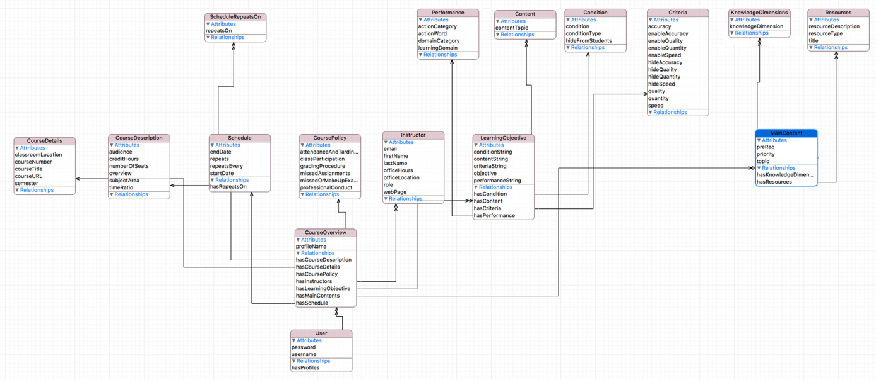

Fig. 7. Database Diagram in the Core-Data Schema

This diagram depicts the various entity objects and their relationships organized for the IMODS Mobile Project and schema designed for the Core-Data [28] which follows the Object Relational Model (ORM) format [27].

4.3 Model View Controller (MVC) Architecture

iOS Mobile Applications typically use Model View Controller (MVC) [24, 25] Design Patterns to typically design the modules. MVC Pattern is a well-known pattern used in various other domains like Desktop Application Programming and Web based Programming paradigms.

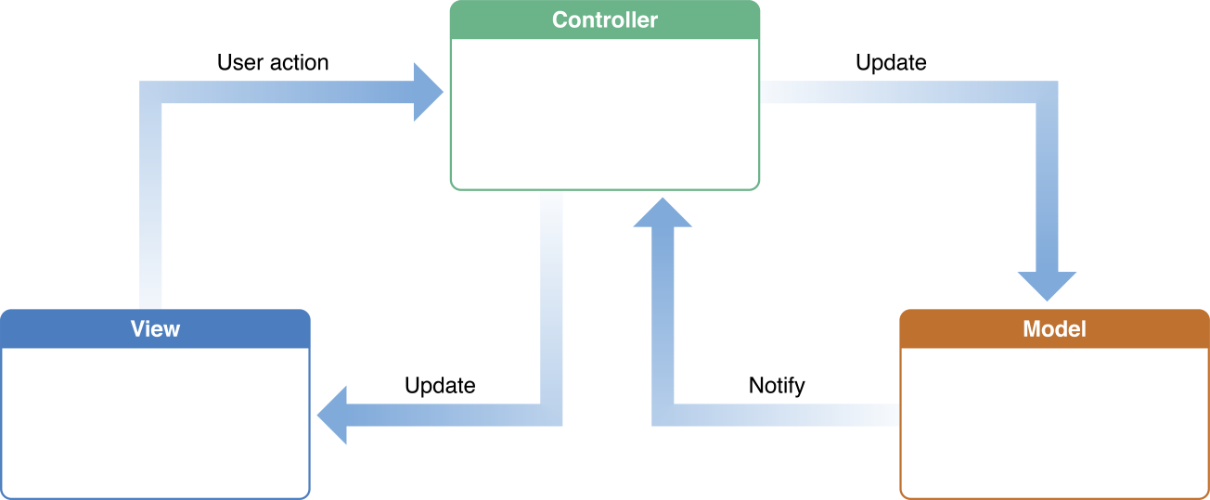

Fig. 8. **MVC (Model View Controller) Design Pattern for iOS Applications.**

The MVC Design pattern assigns objects in an application one of the three roles: model, view and controller. The pattern defines not only the roles objects play in the application, it defines the way objects interact with each other. Each of the three types of objects is separated from the others by abstract borders and connects with the objects of the other types across those borders. The collection of objects of a certain MVC type in an application is sometimes referred to as a layer. E.g. model layer.

Model objects encapsulate the data specific to an application and define the logic and computation that manipulate and process that data. A model object can have to-one and to-many relationships with other model objects, and so sometimes the model layer of an application effectively is one or more object graphs. Much of the data that is part of the persistent state of the application (whether that persistent state is stored in files or databases) should reside in the model objects after the data is loaded into the application. A model object should have no explicit connection to the view objects that present its data and allow users to edit that data—it should not be concerned with user-interface and presentation issues.

A View object is an object in an application that users can see. A view object knows how to draw itself and can respond to user actions. A major purpose of view objects is to display data from the application’s model objects and to enable the editing of that data. Despite this, view objects are typically decoupled from model objects in an MVC application.

A Controller object acts as an intermediary between one or more of an application’s view objects and one or more of its model objects. Controller objects are thus a conduit through which view objects learn about changes in model objects and vice versa. Controller objects can also perform setup and coordinating tasks for an application and manage the life cycles of other objects.

5 DEVELOPMENT AND IMPLEMENTATION

Swift 3.1 was predominantly used as the preferred language base and iOS 10 as the required iOS version to start implementing the mobile application. Swift provides a great amount of flexibility to help a developer engage more in an algorithmic construct of the View Controller and not to worry much about the syntactic influences of the same. The developer environment used is XCode and it provides the in-place evaluation of the code and provide necessary corrections of required which helps in avoiding frequently made errors.

5.1 Model and View Controllers

As part of the development this section will showcase all the View Controllers developed for the functionality of IMODS application in mobile environment.

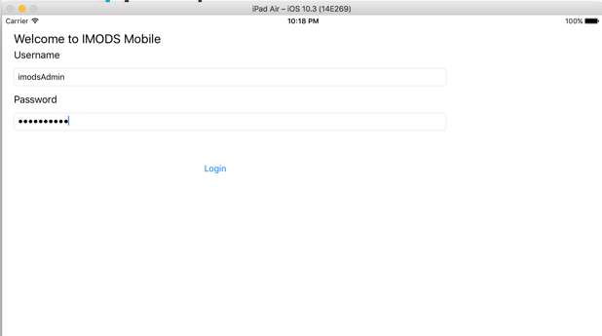 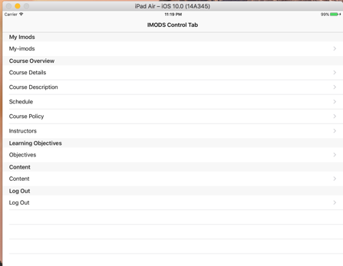

Fig. 9. **Welcome Screen and IMODS Control Screen.**

*5.1.1 Welcome Screen:*When the user opens the IMODS application, he/she will first encounter the Welcome Screen. The user enters the username and password as allocated by the administrator, then the application successfully authenticates and takes to the main screen i.e., IMODS Control Screen.

*5.1.2 IMODS Control Screen:*This will be the first point where user can choose to retrieve a requisite course using the My-imods or create a new IMODS profile for a new course to be taught.

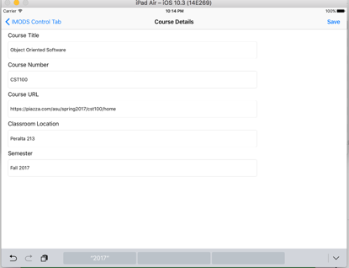 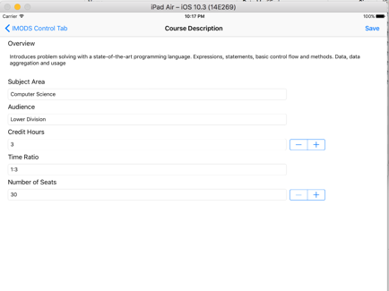 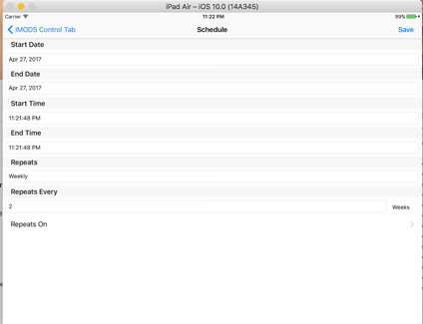

Fig. 10. **Course Details Screen, Course Description Screen and Schedule Screen**

*5.1.3 Course Details Screen:*This screen obtains course details like: Course Title, Course Number, Course URL, Classroom Location and Semester in which the course is being imparted.

*5.1.4 Course Description Screen:*This screen obtains the details of Course Overview, Subject Area, kind of Audience, Credit Hours, Time Ratio and Number of Seats.

*5.1.5 Schedule Screen:*This screen obtains the details of Start Date, End Date and Start Time and End Time and details regarding the repetition of the classes within the course time-frame.

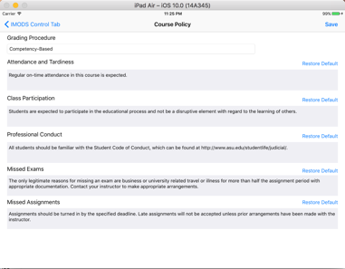 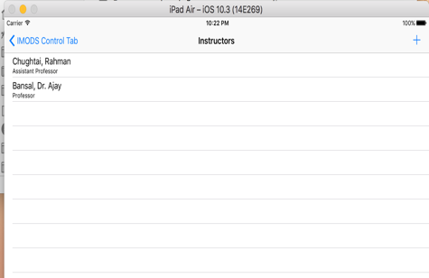 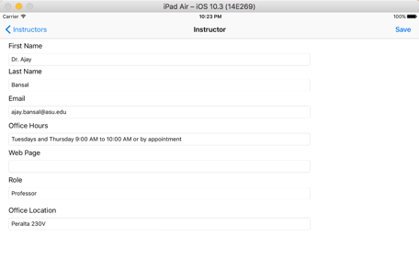

Fig. 11. **Course Policy Screen, Instructors Screen and Instructor Detail Screen**

*5.1.6 Course Policy Screen:*This screen obtains course policy details like: Grading Procedure, Attendance and Tardiness, Class Participation, Professional Conduct, Missed Exams and Missed Assignments.

*5.1.7 Instructors Screen:*This screen shows the list of Instructors and associated personnel with respect to the course.

*5.1.8 Instructor Detail Screen:*This screen shows and can update the details of instructor of interest imparting the course.

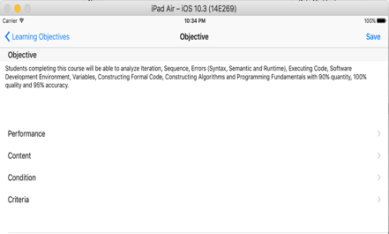 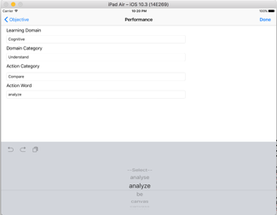 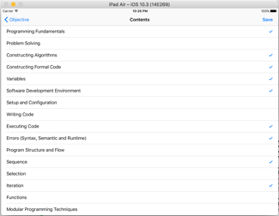

Fig. 12. **Learning Objective Screen, Performance Screen and Content Selection Screen**

*5.1.9 Learning Objective Screen:*This screen is used to set the objective based on the Performance, Content, Condition and Criteria (PC3) Model to set the objectives for outcome based learning for a given course.

*5.1.10 Performance Screen:*This screen shows various learning domains, domain category, action category and action word to pick up right action word for the objective.

*5.1.11 Content Selection Screen:*This screen shows the various content topics to be associated to the objective and choose them accordingly.

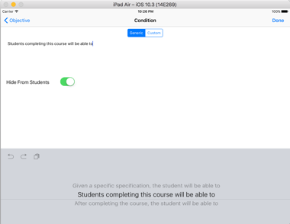 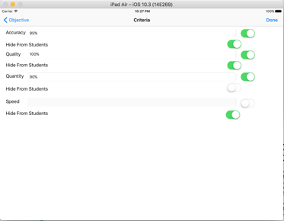

Fig. 13. **Condition Screen and Criteria Screen**

*5.1.12 Condition Screen:*This screen is used to set the objective condition which is part of the objective statement using predefined or a custom definitions.

*5.1.13 Criteria Screen:*This screen is used to set the criteria for the objective such as accuracy, quality, quantity and speed.

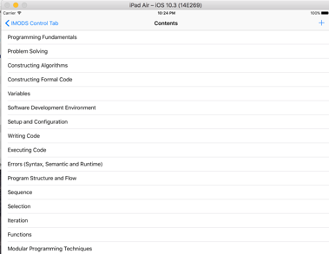 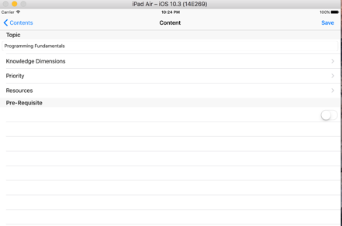

Fig. 14. **Main Contents Screen and Content Detail Screen**

*5.1.14 Main Contents Screen:*This screen is used to add various course contents supporting the course being imparted. In this screen courses can be added, edited and deleted as needed.

*5.1.15 Content Detail Screen:*This screen shows the detailed information of the respective course topic like the topic name, knowledge dimensions, priority and the associated resources supporting the course topic.

5.2 Navigating across View Controllers

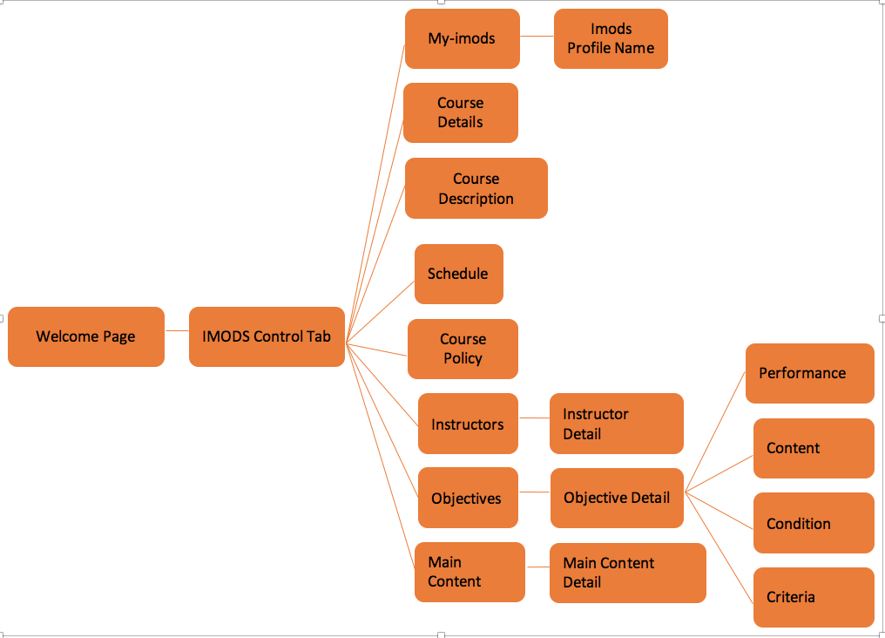

Fig. 15. **Navigation Diagram for various View Controllers in IMODS Mobile App**

The first installment of the IMODS Mobile App for iOS has 18 screens as shown in the above diagram. In the following part, we can see how the various screens can be accessed for viewing and updating various functionalities in the course. As soon as the user opens the mobile app the welcome page will open and prompt the user for username and password. Once successfully authenticated, the app will transition to IMODS Control Tab. This is the main screen, where the user could access to all remaining screens of the IMODS App. Later, the user selects the required course from My-imods screen then the user can move to Course Details, Course Description, Schedule, Course Policy and Instructors to view and update respective standard details pertaining to a course. In the Instructors Screen, the user can add additional instructors and assign various roles in the Instructor Detail Screen to the course imparting instructors. Once all the initial details related to course are updated, the course designer can add multiple learning objectives related to the course by moving to the Objectives Screen. In this screen, the user can add, edit, view and delete objectives related to the course. Once a respective objective is selected or new objective is added, the user will transition to the Objective Detail View, where the user can visualize the objective statement which is in-turn constructed using the Performance, Content, Condition and Criteria for a given learning objective. The crucial parts of the objective will help the user to first pick the action word for the objective using the performance view, next choose the condition of the objective using the condition view and later assign the content topics associated to the objective from the content view and finally assign parameters using the criteria view. The user can also modify the objective statement constructed from its sub-views to make it suitable for further fine tuning. The Content Topics for the course can be set using the main content view where it lists all the topics related to the course. The course designer can add additional topics also assigning the knowledge dimensions, priority and required resources in their respective detail views.

5.3 Source Code Management

I used GIT for source code management that being the popular SCM for iOS App development. The source code for this project can be found in the following location: <https://github.com/IMOD-ASU/imod-mobile> [29]. The Git Client I used to be part of the XCode IDE and it was easy to use.

6 TEST PLANNING AND EXECUTION

During the process of application development, the testing was performed in tandem whilst taking the development activity forward according to the design. The unit tests were performed the following these criteria (i) To verify every view controller’s functionality with respect to the connectivity of the view to controller and to the model (ii) Analyzing whether the required kind of data was being entered respectively in the view (iii) Transition into and outside of the view controller. All the identified unit test defects were fixed in-place before going into the production code. The system testing involved the following criteria (i) Check the model layer connection to view controller tagged to the view, (ii) Check for the response between transition from one view controller to other (iii) Check for User Interface (UI) and connectivity.

7 USABILITY STUDIES AND RESULTS

This development signifies the first part of the IMODS Mobile Development and hence an initial study with respect to the user experience and ease of accessing features help in improving the app further. To facilitate the study, I under the guidance of my faculty mentor designed a user guide which asks the user to perform the steps in-order to traverse all possible features applicable for the first version of IMODS App.

|  |  |  |
| --- | --- | --- |
| Sl No | Criteria | Average Rating Received out of 5 |
| 1 | Information Organization | 3.8 / 5.0 |
| 2 | Error Messages | 3.2 / 5.0 |
| 3 | Need Supporting Document | 3.4 / 5.0 |
| 4 | Easy to Navigate | 3.6 / 5.0 |
| 5 | Font Size and Style | 4.2 / 5.0 |
| 6 | Intuitiveness | 3.0 / 5.0 |
| 7 | Overall Satisfaction | 3.6 / 5.0 |
| 8 | Recommend to Others | 3.6 / 5.0 |

Table 1. User Study Results for Initial IMODS Application and User Feedback

The user study was performed by a closed set of audiences, where 50% had previously used the IMODS web application and rest of them were unaware of the IMODS framework. The user study was performed in the following way. Initially the development team in consultation with the faculty mentor created a usability instructions document which it contained a list of contiguous steps to be performed on the application along with the time to be taken to perform those requisite steps accordingly. These tests were primarily conducted on iPads of various sizes and models having iOS 10.0 or above. Once the end-user completes all the steps, then the feedback was collected covering various areas of the application. The average rating for the 8 specific areas can be seen in Table 1. The overall satisfaction was at 3.6 / 5.0 which is a significant rating considering the mobile app being the first alpha version.

The users who were already well-versed with the IMODS web application also provided valuable feedback and suggestions on certain parts of the application. To summarize the main ones: (i) provide tooltips to make it for the first-time users easy, (ii) Warn the user if he loses data due to moving back to the previous screen in-case by mistake, (iii) Certain input validations to be performed mainly for email address and mobile phone numbers etc. There were some of the positive feedback with respect to the health of the application i.e., the mobile app not crashing at any point of time, (ii) Certain UI elements like Date Picker or Word Picker makes the user’s life easier, (iii) There were sufficient instructions provided especially for Instructor Creation list, Objective Creation list and Content Creation List to aid the end-user create the same.

8 FUTURE WORK

As part of the next phase of the project, it will be necessary to build a JSON RPC Server on the Server side which will be hosting the users and their respective data. Also, the IMODS Web Application was written in groovy script and the groovy script supports building a JSON RPC Server. Once the JSON RPC Server is developed then there needs to be a standard to converting the data exchange object (JSON) object which provides the data required to be convertible into ORM (Object Relational Model) [27] for Core Data in iOS App and primarily RDM (Relational Database Model) for PostGreSQL in Web App as a pre-requisite. Later App need to be implement to authenticate against the RPC Server and then communicate using JSON Object over the RPC also convert the data into required ORM Objects. For the future phases can contain Application Assessment, Pedagogy and Schedule Tabs of the Web Application implemented in the mobile application.

9 CONCLUSIONS

This report talks about all the activities I have performed from the initial inception for IMODS Mobile Project till the end of delivery of the first stage of the project. My initial task was understanding the basic of usage of the Web Application for the IMODS Application and getting to know the reason behind all the required screens and tabs of the web application and frame the requirements with respect to the mobile environment.

Once the understanding of the web application is complete, then the feasibility study was performed as to what kind of mobile environments were to be used by the user. After a brief research and numerous back and forth discussions with the faculty mentor we had zeroed on to develop the application for iOS environment and to target the iPad family of devices.

Later the system architectural design (HLD) and detailed low level design (LLD) was performed for the mobile application and once they were approved the implementation mock-ups were created as to look how all the screens will be appear visually to the user and later implemented the same using XCode IDE. There were many decisions taken during the entire duration of development and judgements made on the various navigational paths and placement of the respective screens to make the application apt for its usability.

Personally, for me it is been a pleasure working under guidance of the faculty mentor who has constantly pushed to come-up with new navigational ideas and use state-of-the-art widgets to make the complex web application usable in the mobile environment.

ACKNOWLEDGMENTS

This project was from the time of inception till the delivery was supported by my faculty mentor Prof. Srividya Bansal who sought to guide me through the entire duration. I would like to extend my deepest gratitude for Prof. Bansal in this regard. I would like to personally thank all the members of the research group who took their time to participate in the user study performed for the IMODS mobile application.

REFERENCES

|  |  |
| --- | --- |
| [1] | IMODS Wikipedia - <http://imod-asu.weebly.com> |
| [2] | IMODS Project Overview - <http://imod-asu.weebly.com/project-overview.html> |
| [3] | R. M. Harden, J. R. Crosby, M. H. Davis, and M. Friedman, “AMEE Guide No. 14: Outcome-based Education: Part 5--From Competency to Meta- Competency: A Model for the Specification of Learning Outcomes.,” Medical Teacher, vol. 21, no. 6, pp. 546– 552, 1999. |
| [4] | W. G. Spady, “Organizing for Results: The Basis of Authentic Restructuring and Reform.,” Educational Leadership, vol. 46, no. 2, pp. 4–8, 1988. |
| [5] | G. C. Furman, “Outcome-Based Education and Accountability.,” Education and Urban Society, vol. 26, no. 4, pp. 417–437, 1994 |
| [6] | O. Dalrymple, S. Bansal, A. Gaffar, and R. Taylor, “Instructional Module Development (IMOD) System: A User Study on Curriculum Design Process,” in Frontiers in Education (FIE), Madrid, Spain, 2014. |
| [7] | S. Bansal, O. Dalrymple, A. Gaffar, and R. Taylor, “User Research for the Instructional Module Development (IMOD) System,” in American Society for Engineering Education Annual Conference (ASEE), Indianapolis, IN, 2014. |
| [8] | J. Lazar, J. H. Feng, and H. Hochheiser, Research methods in human-computer interaction. John Wiley & Sons Inc, 2009. |
| [9] | Odesma Dalrymple,  Srividya Bansal, Kavitha Elamparithi, Husna Gafoor, Adam Lay, Saishruti Shetty.  "[Instructional Module Development (IMOD) System: Building Faculty Expertise in Outcome-based Course design](http://imod-asu.weebly.com/uploads/2/9/6/3/29635095/imod-fie-2013.pdf" \t "_blank)". In Proceedings of Frontiers in Education Conference (FIE), October 2013, Oklahoma City, USA. |
| [10] | K. Andhare, O. Dalrymple, and S. Bansal, “Learning Objectives Feature for Instructional Module Development System,” presented at the PSW American Society for Engineering Education Conference, San Luis Obispo, California, 2012. |
| [11] | Srividya K Bansal, Odesma Dalrymple, Ashraf Gaffar. "[﻿﻿﻿Design, Development, and Implementation of the Instructional Module Development System (IMODS)](http://imod-asu.weebly.com/uploads/2/9/6/3/29635095/asee-2015-final(nsfgranteessession).pdf" \t "_blank)﻿﻿﻿", in Proceedings of American Society for Engineering Education Conference(ASEE) - NSF Grantees session, June 2015, Seattle, USA |
| [12] | Srividya Bansal, Odesma Dalrymple, Vishnu Menon, Ketaki Andhare, Vrushali Moghe;[IMOD: Semantic Web-based Instructional Module Development System](https://f004f886-a-0c9971f9-s-sites.googlegroups.com/a/asu.edu/imod/pubs/IMoD-SEA2012_CameraReady.pdf?attachauth=ANoY7co_KJC5CxLiBq0cykJmAsV26IoyZ70Z7BAxk9dRrxygMrN6I4moFq9b1zk_UWDCmzethnIYasRjqT8ZFEIUsvifr0vCOxP8qcjYkchwWCuaffZnPjssljOWoSmtWrOAYRxiMsXqaTqpd8gBU2iWWJ0KV6VBFHIK3F2mRQVrM_CGoHl0T3mDYPYH1CTj0hpTeM5XKhEu-ny1AjMduvD8yfs0Qx8LR9XOUPbGblY7gd3LZqDRqwU%3D&attredirects=0) in the Proceedings of the 2012 IASTED Software Engineering and Applications Conference (SEA), Las Vegas, Nevada. |
| [13] | IMODS Web Application - <http://imod.poly.asu.edu:8080/imod-test/content/index/6976> |
| [14] | An iOS Application - iHomeWork - <https://itunes.apple.com/us/app/ihomework/id408823699?mt=12> |
| [15] | An iOS Application - Graphmatica - <https://itunes.apple.com/us/app/graphmatica/id536792706?mt=12> |
| [16] | Blackboard – An application used for imparting stem education - <http://www.blackboard.com> |
| [17] | Moodle – An open source learning platform or course management system (CMS) - <https://moodle.org> |
| [18] | Coursera – An Open University Topic Education Aggregator - <https://www.coursera.org> |
| [19] | Khan Academy – A non-profit organization trying to make education free across the globe - <https://www.khanacademy.org> |
| [20] | Udacity – It is a for-profit education organization offering massive open online courses - <https://www.udacity.com> |
| [21] | Udemy – An online learning platforms aimed at skilling professionals who want to learn new skills - <https://www.udemy.com/courses/> |
| [22] | Lynda – Another online platform offering courses in software, creative and business skill - <https://www.lynda.com> |
| [23] | Code School – Interactive Courses for aspiring and experienced developers - <https://www.codeschool.com> |
| [24] | Model View Controller Design Pattern for iOS Applications - <https://developer.apple.com/library/content/documentation/General/Conceptual/DevPedia-CocoaCore/MVC.html> |
| [25] | Model View Controller for Applications - <https://en.wikipedia.org/wiki/Model–view–controller> |
| [26] | UML Diagrams from Astah - <http://astah.net/tutorial> |
| [27] | Object Relational Database - <https://en.wikipedia.org/wiki/Object-relational_database> |
| [28] | Core Data Programming Guide for iOS - <https://developer.apple.com/library/content/documentation/Cocoa/Conceptual/CoreData/index.html?utm_source=iosstash.io> |
| [29] | IMODS Git Hub - <https://github.com/IMOD-ASU> |
|  |  |